Chapter 3: Implementation
“There exists a universe inhabited by a will
so powerful
that every other will
is its own.

A creature of colossal dimensions
that feeds on souls.

And all souls,
all of them,
belong to it.”

Fabhrius.
(from the book, 'Rainland's Lost Codex')

Introduction

Now, let's see how we can utilize the ideas we've discussed
to create a machine that automatically solves logical problems.

The objective of this chapter will be to understand how the system is formed, what its components are,
and to envision this machine in action
to grasp the mechanism that allows it to find solutions.

In this computer model,
the configuration of the machine
and the problem
are closely related,
so we will start by defining
the problem we want to solve.

Once the problem is defined,
we'll examine the structure of the machine in a generic manner,
and then,
adapt the generic machine
to the specific problem
it will be assigned to.

After this,
we will set the system in motion
to observe how it solves the problem.

The Problem
As an example, we will use a simple problem that allows us to focus all our attention on how the machine works without being distracted by details.

We will use a board game called "Maze" for this purpose.

The objective of the game is
to find the path that leads from the entrance to the exit of a maze.
It will be played on an 8 by 8 grid board, similar to the one used in chess.

Each square on the board
can be referenced with a name formed by the concatenation of a letter and a number, such as 'A1', where the columns are referenced by a letter from 'A' to 'H', and the rows are referenced by a number from 1 to 8.

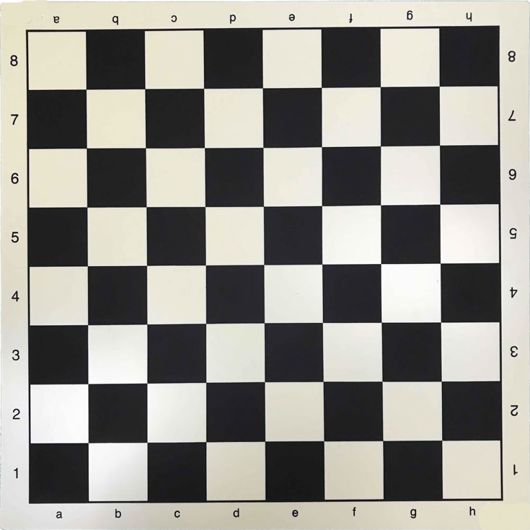

We will mark on the board a square representing the entrance to the maze, which will be square 'A1',
and another square representing the exit of the maze, which will be square 'H8'.

We will place a single token on the board to represent a character that must navigate the maze.

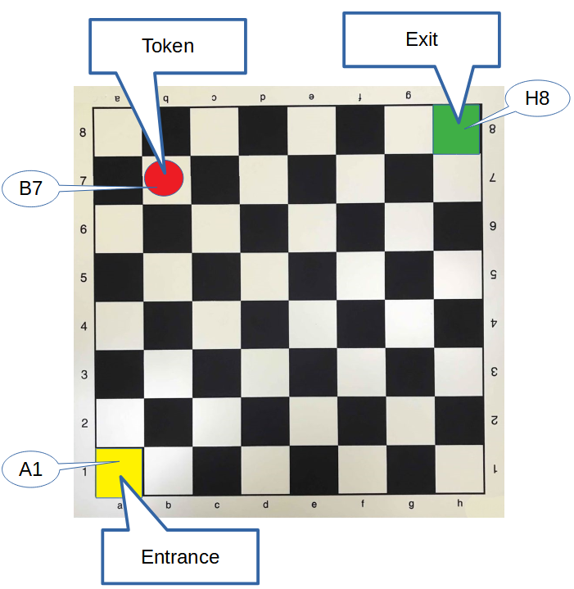

The token can move in any direction but only to an adjacent square with each move.
Therefore, any movement that moves the token one square away will be considered a valid move.

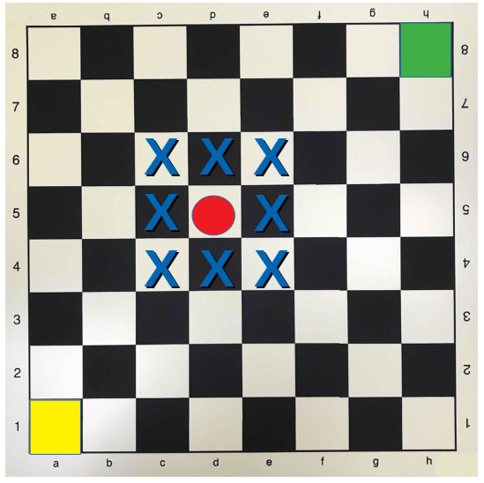

And with this,
we have defined the game and the problem we want to solve.

In summary, what the machine should tell us is:

"What is the path
that the token must follow
to go from the entrance to the exit of the maze?"

Computers, conceptually, can be divided into two parts:
The Machine
software and hardware.

Software is the logical part,
composed of ideas.

Hardware is the physical part.

Someone once told me that hardware is something that can be broken with a blow.

As we have discussed, information processing involves two elements:
data and method.
And a machine that processes information must have a memory support to hold the data and a mechanism to apply the appropriate operations on the data, executing the method, i.e., a processor.
Data and memory, method and processor.

Data and method
are the software part of the machine; they are ideas.

Memory and processor
are hardware; they are the physical part, and in the computers we use daily, they are made up of electronic circuits.

The logical part is already established,
Software
given by the description of the problem we have outlined.

.
The data
(which describe the context)
must depict the maze game
and the states
through which the game will pass.

The method
(the operations to be performed on the data)
will be the one that generates the next possible state, that is, making a valid move.
The token can only move to an adjacent square with each move.

Hardware
The physical part of the machine, which consists of:
• a memory support, and
• a processing mechanism.

We have previously discussed that there are two characteristics present in all living beings that can be used to fulfill these functions, and these are:

DNA,
which stores information
like a read-only memory, and

the reproduction mechanism,
which modifies the information contained in the DNA to create a new strand.

Therefore, we will use
DNA as memory and
the reproduction mechanism as a processor.

With this, we have all the necessary elements to create the computing system.

Now let's see how we adapt the system
Adjustment
to the problem we want to solve.
In a system of this kind, the machine must be tailored to fit the problem.
We will adapt a branch of life to this specific problem,
with the data we have about it.
We will achieve this by creating a new species of living beings
specific to the maze problem.

A species is
a family of similar individuals.
All individuals of a species are
very alike, not identical, but almost.

Thus, it is the individual that
defines the species.

We will create a new species simply by creating an individual
with the characteristics that interest us.
All living creatures follow a life cycle that consists of
being born, reproducing, and dying.

Therefore, once the new individual we need is created,
it will reproduce and create the new species.

It is simply a matter of creating the right individual.

Let's see how.

The Individual
DNA is present in all living creatures.
In all individuals of all species.
DNA contains the necessary information to construct an individual.

We will use DNA
as the memory of the system,

and we will store in it the information necessary to reconstruct any state of the problem-solving process we are working on.

In this case, we are dealing with a board game.
Therefore,
an individual of this new species should represent a state in the maze game.

Let's see what data we need to summarize a game state.

State
Let's say we are playing a game of chess, and the game is already in an intermediate state when we have to leave it. And we would like to be able to continue playing this same game tomorrow from the exact point where we left off today.

For this, it will be necessary to remember the "state" in which the game was left. In the case of a game of chess, it would suffice to remember:

- the position of the pieces on the board
- and which of the two players will make the next move.

With this information, we could reconstruct the game to continue from the same point.

This is the information that describes the state

In the case of the maze game, to remember a state, it will be sufficient to remember:
Materialization

- the position of the single token on the board, and

- all the movements that have been made up to that moment. This will allow us to remember the path the token has taken as well.

In summary,
to address the problem of the maze game,
we will create a new species of living beings where
the individual will be
a board with a token
in a specific position,

and a list of ancestors.
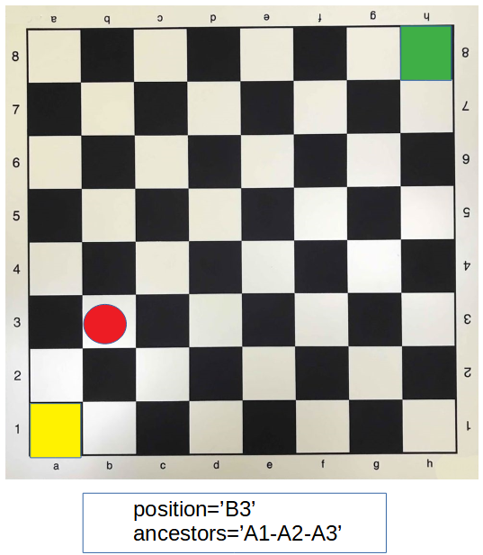
plus a list containing all the movements that have been made up to that moment.

The first individual of the species will not have ancestors, and therefore its list of ancestors will be empty. When reproducing, it will pass on its list of ancestors to its children, adding its own position to the end of the list. This way, the list of ancestors will grow generation after generation.

Living beings reproduce.
The number of offspring created in a single generation varies depending on the species. In the case of some mammals, such as humans, elephants, or whales, typically, only one offspring is created in each generation. A cockroach may lay around 15 eggs. Corn will produce around 600 offspring.
Meanwhile, a sunfish can lay 300 million eggs in a single spawning event.

Thus,
the number of offspring will adapt to the particular needs of each species.

For the case of the new species we are creating in this experiment,
we will have the individual create all possible offspring in the first generation. That is, one offspring for each valid move,
and all of them will be created in the first generation.
And once its offspring are created, the individual will die.

All possible children for 'A1'
will be those where the token is one square away from A1.

Three in total as the following graph shows

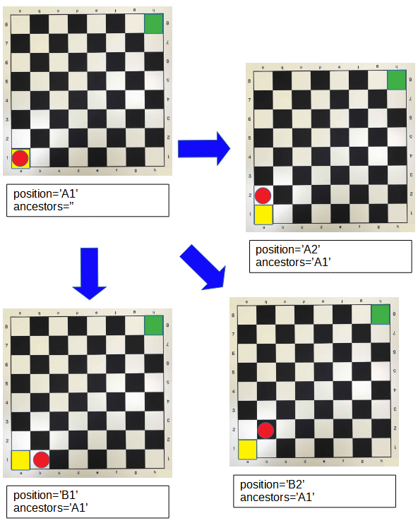

Now that we have seen what an individual of this species should be like, let's see how a system of this type would solve the problem.
Start Up

To set this machine in motion, initiating the calculation process,
we will begin by creating an individual
that represents the initial state of the problem.

That is, a board with the token at the entrance of the maze, position 'A1'.

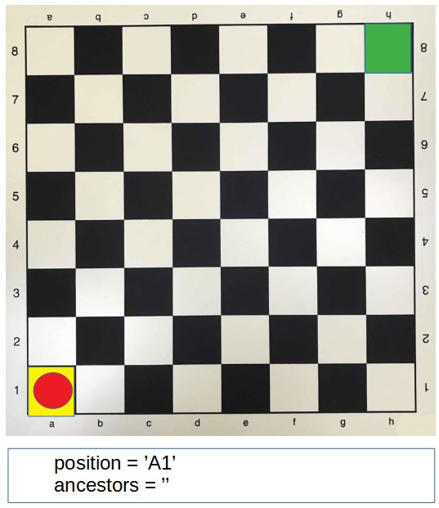

The next step will be to imbue this individual with life.

And that's it.

Because when this individual awakens to life, the following happens.

Now that 'A1' is alive,
it will have children.
It will have all possible ones,
and they will occupy the positions (marked with X)
shown in figure 7.

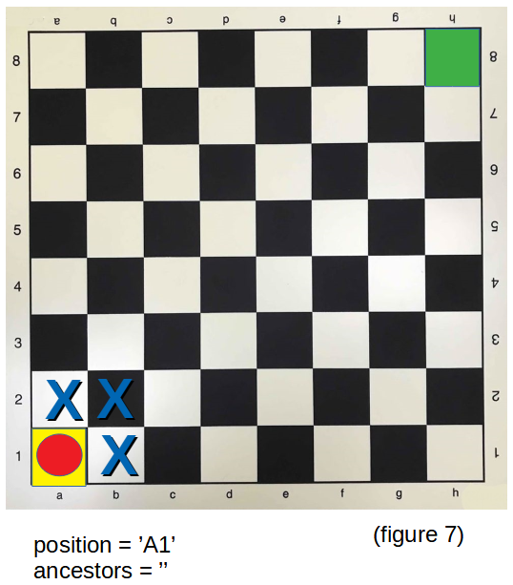

So, among them is born 'B2'
(figure 8).

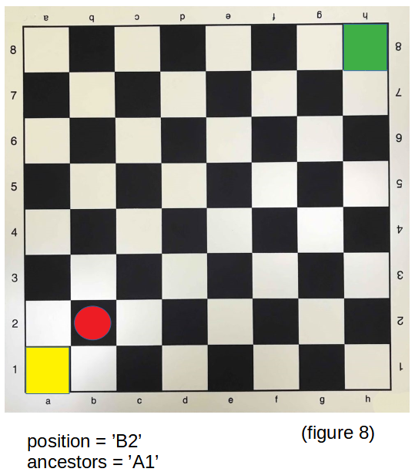

Now that 'B2' is alive,
it will have children.
It will have all possible ones,
and they will occupy the positions (marked with X)
shown in figure 9.

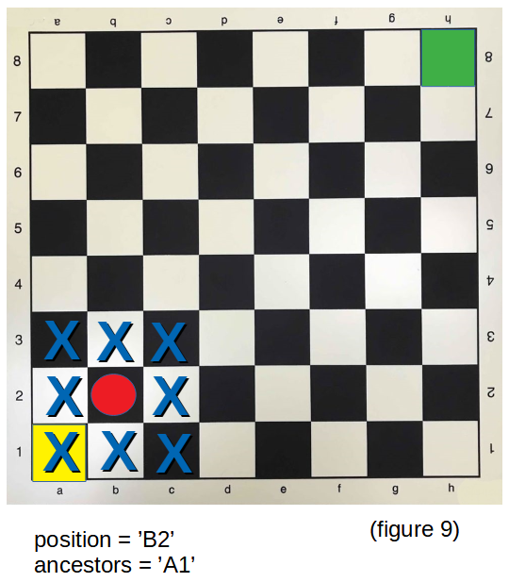

So, among them is born 'C3'
(figure 10).

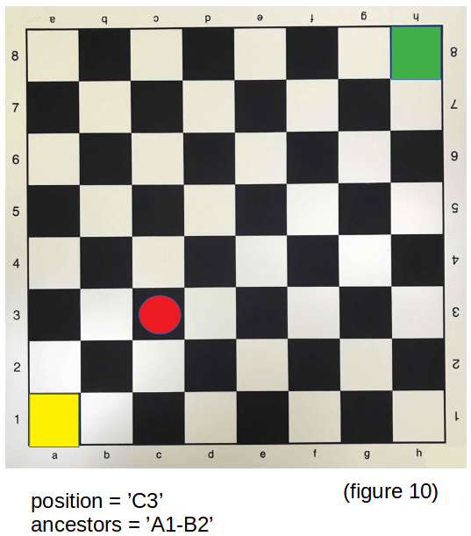

Now that 'C3' is alive,
it will have children.
It will have all possible ones,
and they will occupy the positions (marked with X)
shown in figure 11.

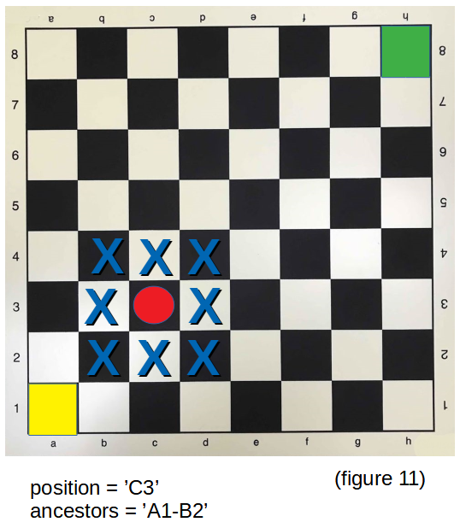

So, among them is born 'D4'
(figure 12).

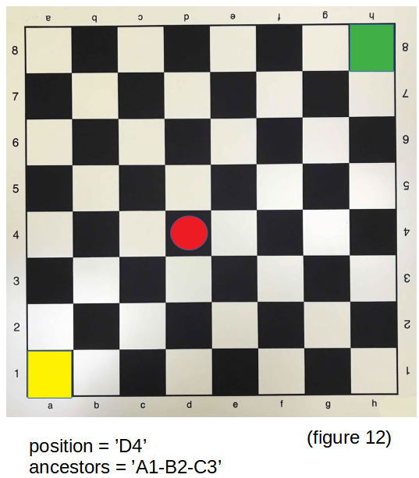

Now that 'D4' is alive,
it will have children.
It will have all possible ones,
and they will occupy the positions (marked with X)
shown in figure 13.

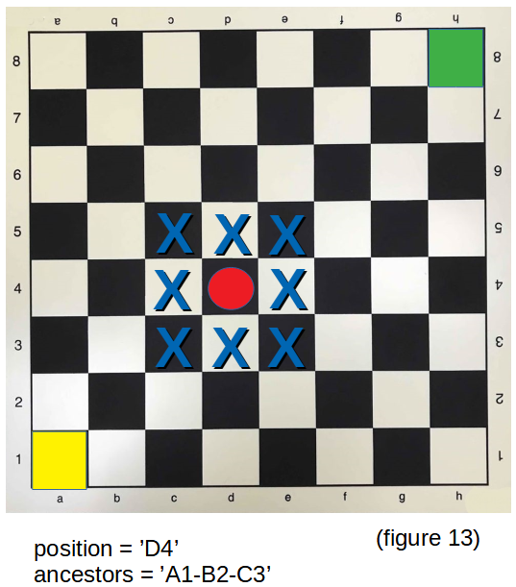

So, among them is born 'E5'
(figure 14).

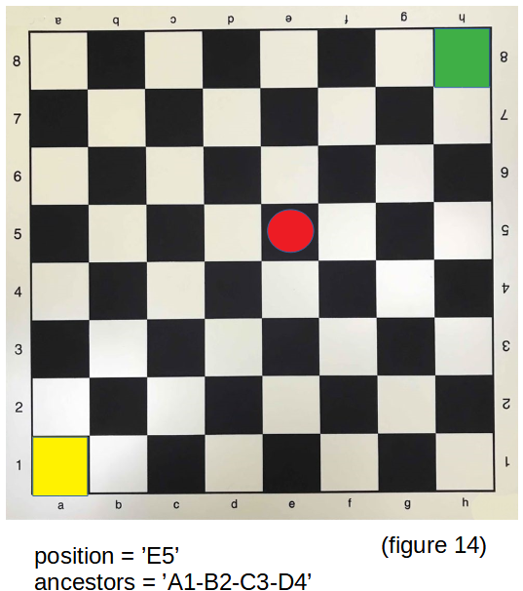

Now that 'E5' is alive,
it will have children.
It will have all possible ones,
and they will occupy the positions (marked with X)
shown in figure 15.

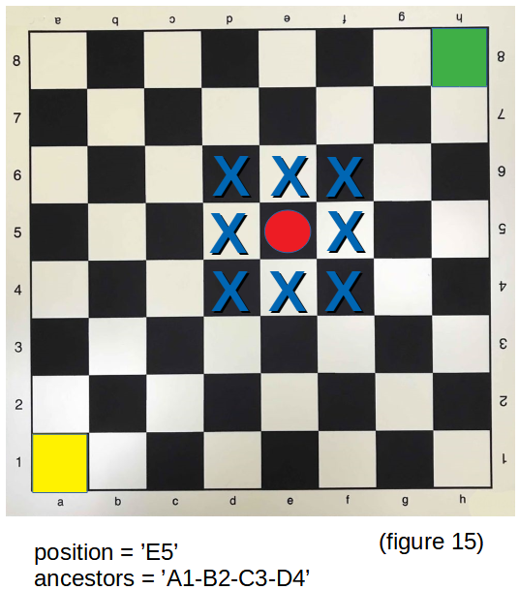

So, among them is born 'F6'
(figure 16).

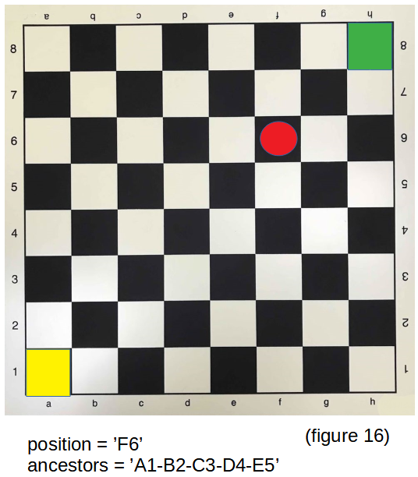

Now that 'F6' is alive,
it will have children.
It will have all possible ones,
and they will occupy the positions (marked with X)
shown in figure 17.

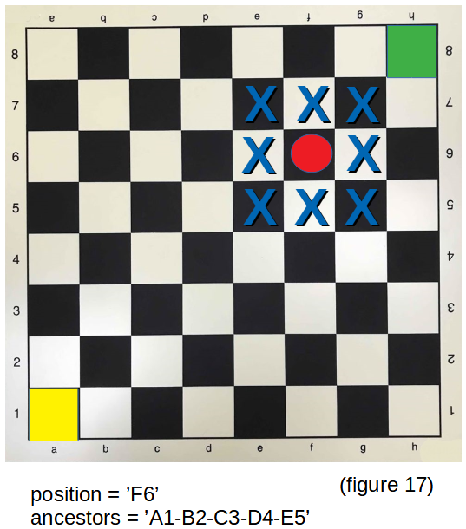

So, among them is born 'G7'
(figure 18).

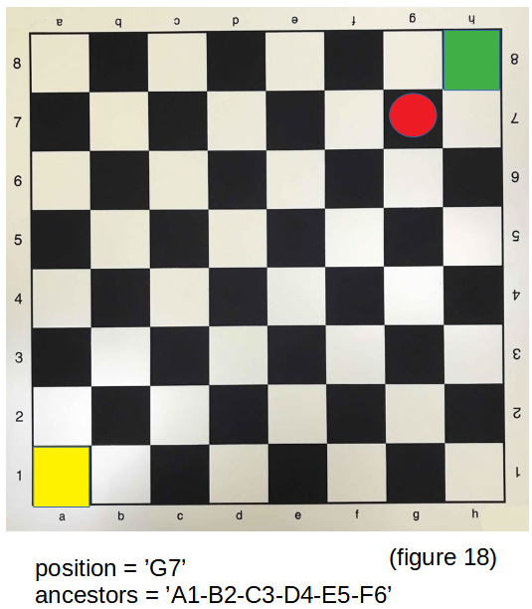

Now that 'G7' is alive,
it will have children.
It will have all possible ones,
and they will occupy the positions (marked with X)
shown in figure 19.

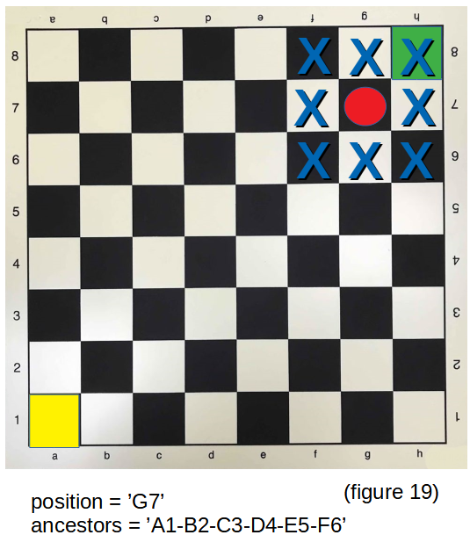

So, among them is born 'H8'
(figure 20).

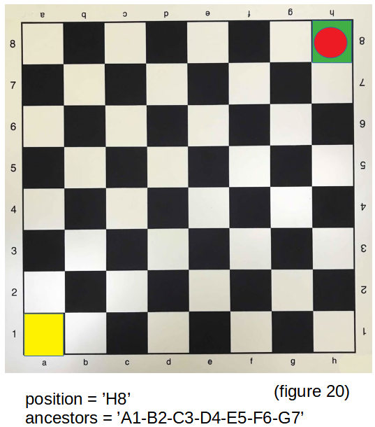

This individual 'H8'
represents the final state we wanted to achieve.

And it has the solution to the problem.
Its list of ancestors is:
- "A1-B2-C3-D4-E5-F6-G7" -

And that is the answer,
the path that leads from the entrance to the exit of the maze.

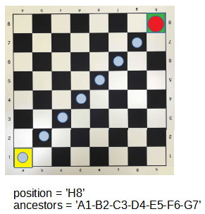

What has happened?

The system has found the answer we were looking for.

However, the individuals that have been created in the process
had no knowledge of the problem,
or the calculation process that was taking place.

The individuals live their lives unaware of the calculation process.

And there is nothing the individual can do
to alter the calculation result.

El individuo no sabe porque tiene esta forma particular, y no tiene control sobre esto.
El individuo no sabe porque ha nacido, y no tiene control sobre esto.
El individuo no sabe porque debe reproducirse, y no tiene control sobre esto.
El individuo no sabe porque debe morir, y no tienen control sobre esto.

El individuo no sabe que un proceso se esta llevando a cabo. Y no hay nada que el individuo pueda hacer que altere el resultado del calculo.

En las próximas paginas comentaremos con mas detalle acerca de la necesidad de que los individuos cumplan con un ciclo de vida y veremos el porque de cada una de las etapas.
Pero antes, empezaremos por analizar las características mas relevantes de este sistema inteligente.

